**Illawarra Sports High School Newsletter**

September, 21st, 2010, Week 10, Term 3

**The Principal’s Report**

This week sees the Graduation of our Year 12 HSC students. This is a very exciting time for the students and their parents as it signifies the completion of school education, which has been a significant part of life for a long time. The students will hopefully progress into other forms of education, including University, TAFE, traineeships and workplace learning. All of the skills learnt at school will be used to continue with the career path of choice. Each of our students has progressed from an inexperienced high school student through to a well educated and informed member of our wider community. I am looking forward to the Graduation as an opportunity to congratulate each student and to see the proud faces of each parent as the graduates are presented. May I thank each parent for the huge effort you have given to these young people over the years. I am sure there were times that were challenging and times when things went exactly to plan, and in the long run, it has been worth every minute of time given to see the success of these young people. Well done and Congratulations.

Our Year 11 students are completing their Preliminary Exams and looking forward to becoming our new HSC group next Term.

During last Monday’s Assembly, Mr Ben Rehmie visited our school to introduce a website for supporters of X League. X League is the company who approached Illawarra Sports High over 2 years ago to propose a new synthetic grass field for our school. The project is to include a world class playing field for Football and Rugby League/Union and 10 small fields for Futsal and other small field sports. The facility would also feature a clubhouse with change rooms, meeting room, canteen and foyer supported by a 80 space car park. Mr Rehmie and I have been negotiating with the Department of Education and Training to secure this facility for Illawarra Sports High and the Illawarra. The website support is open to all students, parents and community supporters of Football and Rugby League/Union. Supporters forms are available from Illawarra Sports High.

The Bill Turner Cup Football team played their way into 3rd place in the National Championship recently following a highly motivated match against Queensland’s best. The defeat the previous day during the playoff for the Grand Final was put behind them and a spirited effort by our young team demonstrated the excellence these players have. We all congratulate the team and the coaching staff for a wonderful achievement.

The HSC Visual Arts and Photographic students opened their gallery to the public last Thursday night. This provided an opportunity for these extremely talented students to display their ‘Body of Work’ as an example of their creativity and skill. The display will now be examined by a team of Board of Studies examiners, as a component of the HSC examination.

The Spring Vacation begins this Friday for two weeks and I wish the students and staff a safe and enjoyable holiday. To the families, it is a chance to spend some quality time together without the regular daily routine of heading off to school by 8.30. We look forward to Term 4 and upcoming warmer months. Have a good holiday.

Dr Peter Bailey, Principal

**Sports Report**

Although our fantastic sporting performances have continued during the past fortnight, we must dedicate our opening report to our graduating Year 12 students, who finalise their class commitments this week. Their collective contributions to the development and success of this school has been very significant.

**The Class Of 2010 Will Be A Hard Act To Follow:** Like every year at this time, it will be sad to farewell a great group of young men and women, who have evolved from the ‘fresh faced, question filled’ students who arrived here in 2005.

Professionally, many have developed into elite athletes who should transfer their sporting talent into a fulltime career. Others will continue to play at a high level, whilst the majority of leavers will hopefully continue to participate in the wide variety of activities that they have been involved in, during the last six years.

Unfortunately, statistics will reveal that the end of secondary schooling, often results in less sporting and physical activity. After nominating so many Year 12 students for contribution to sport awards, it would be disappointing to hear of “premature retirements” in the next twelve or eighteen months, of so many wonderful participants.

Apart from the obvious health reasons, it is crucial that you pursue your sporting interests in the future. Each and every one of you have brought a great deal of fun and enjoyment to the sporting environment that you have been involved with. As a sportsman myself, your absence from that environment, will leave everyone else “poorer” for the experience.

So on behalf of the extensive sporting culture at the school, good luck in all your future endeavours and please remember my final parting words, **“Don’t ever retire”**. The aches and pains will go away but the enjoyment and memories never will!

**24 Hours Of Fun And Enjoyment (and a little exercise):** Speaking of never retiring, it has been encouraging to receive a large number of adult entries for “24 Hours To Beijing.” The twenty four hours of non-stop indoor football (soccer) is only days away, commencing this Friday at 6 pm with the fun, festivities and music continuing until the same time on Saturday. Money raised from the $5 playing fee will help send Jack Keating to China in January with the Australian Schoolboys Team. Apart from the Keating family who will be firing up the BBQ, can I thank a number of parents in advance for their kind donation of salads and other recipes, which will be complimentary during the event.

It will be an enjoyable start to the September break……if you would like to join in there are still spots available, regardless of whether you have a team (of five) or whether you would just like to come along by yourself.

This event is for anyone and everyone who likes to enjoy themselves and contribute to a great cause.

If you would like to be part of it, contact Darren / Neridah on 42711099, Ext. 147 or 0411258836 or email Darren, [darren.nunn@det.nsw.edu.au](mailto:darren.nunn@det.nsw.edu.au)

**Bill Turner Cup Boys Do Us Proud:** Our strong tradition in the 600 team Bill Turner Cup competition, has continued following another outstanding performance in the “Final Four Shootout” in Newcastle last week.

After we were defeated by eventual champions, Westfields Sports High School in the semi-final, our boys produced a magnificent effort in their 4-0 shutout of Cavendish Road Sports High School, the Queensland champions, in the bronze medal play-off match. In finishing third, the boys clearly stamped themselves as an “elite team”, and one that deserves to be competing at the highest level in the country.

In a wonderful team effort, two of our boys received prestigious awards for their performance during the series.

Jack Madgwick was selected as the Most Valuable Player (MVP) of the “Final Four Shootout”, which was a tremendous achievement, considering that the best 15 year old players in the country participated in this event.

Superb goalkeeping from Jake Webster earned him the Player’s Player Award from his team mates, which was great recognition for his outstanding performance between the sticks, and a huge achievement considering he outvoted Jack

To Mr Thompson, who coached the squad throughout the year, congratulations on a fine achievement, particularly considering the number of “young” players involved in the squad.

To everyone else who contributed (parents; student mentors, Guy Knight and Dejan Djukic and our other elite coaches who assisted during the year, Alfredo, Glenn Fontana and Chris Jackson) congratulations on behalf of the school for keeping our proud football tradition intact.

**Baseballers Again Amongst The Best In The State:** Despite being defeated by The Hills Sports High School in the semi finals of the CHS Knockout, our boys once again proved that it is quality not quantity that characterises our ongoing prowess in the sport. Our small but talented playing group, trailed by one run for the majority of the match, before the score blew out in the last innings.

We once again salute the entire squad, along with Mr Balange, Mr Borg and Mr Parsons who assisted during the last match, for their high level achievements this year.

**Targeted Sport Programs Continuing Next Term:** Rugby League, Tennis and Hockey will continue training with their squads in Term 4. All other athletes in their respective programs will participate in Recreational Sport. (All students were informed of this several weeks ago and they have signed up for a ‘Rec’ sport.)

Later in the term, all TSP students will participate in running technique training and other forms of Track and Field training, which will assist in their overall development.

**Enjoy The Break:** To students, parents and all members of the Illawarra Sports HS ‘family’, we hope that you have a safe, relaxing and enjoyable holiday period and we will see you back ‘recharged’, on the first day next term.

**SCHOOL TRANSPORT NOTICE**

**IMPORTANT CHANGES TO TRAIN AND BUS TIMETABLES - FOR TERM 4**

All train travellers please note that a new train timetable commences October, 10th. These can be accessed through City Rail.

Premier Illawarra Bus Company is now in the process of finalising new schedules to co-ordinate with these changes, which will be available soon on their website.

**OPEN FOR SCIENCE**

**Written by Sean Tait**

**Photography by Farah**

First used by students and staff in mid 2009. Among the guests of the official opening were Honorary Member for Wollongong Noreen Hay, School Education Directors, David Phipps and Christopher Conner, and principals of primary schools throughout the Illawarra region.

Held in room C1, or 44, the ceremony began at 10:00a.m. with the arrival of the guests before the land was acknowledged by Mrs. Lisa Poole, Aboriginal Education Officer.

“Yalunga, yalunga, yalunga”, said Mrs. Poole, “which in my people’s language means ‘welcome’".

The construction, completed in two stages to allow for the continuation of study, saw more than just an upgrade but also the introduction of ‘wet’ and ‘dry’ areas.

“They are of the very latest design”, said Mrs. Hay, “They include the innovative ‘wet’ and ‘dry’ areas whereby the students conduct the fascinating processes of experimentation and return to their notebooks or laptops to record their findings and establish conclusions. With these much needed upgrades, our students continue to achieve results that match the best in the world.”

So while the staff and outside community members seem happy with the makeovers, how does the student body feel about the new facilities?

“They provide a safe, clean and productive learning environment”, said Stephen Smith, Year 10 SRC representative. “Now the labs have all the necessary equipment and safety devices for injury free, successful lessons.”

Walking around the classes to view some of the experiments being conducted, Dr. Bailey seemed relieved and overjoyed with the results.

“To provide the news to the staff and students was one of those wonderful moments. So to see the students doing their work is just marvellous.”

With these facilities now open, hopefully one day we might see one of our own students spoken of highly by some of the top scientists in the world. Would a Noble Prize be asking too much guys?

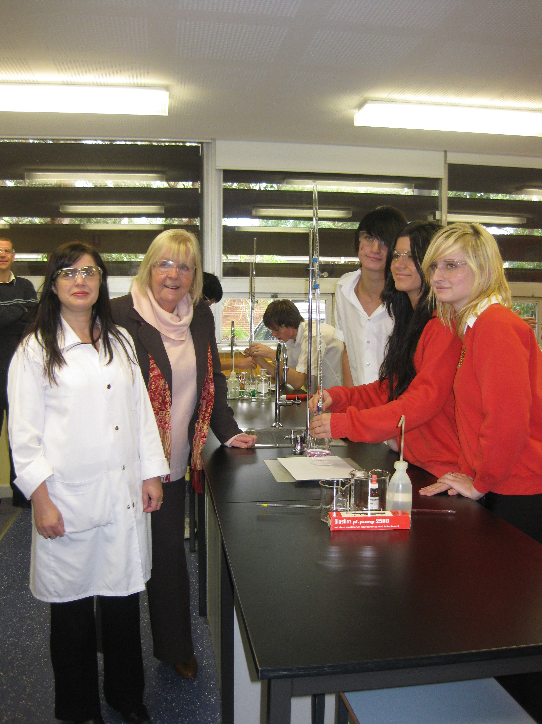

**Hon. Noreen Hay Reviewing a Year 12 Chemistry Experiment**

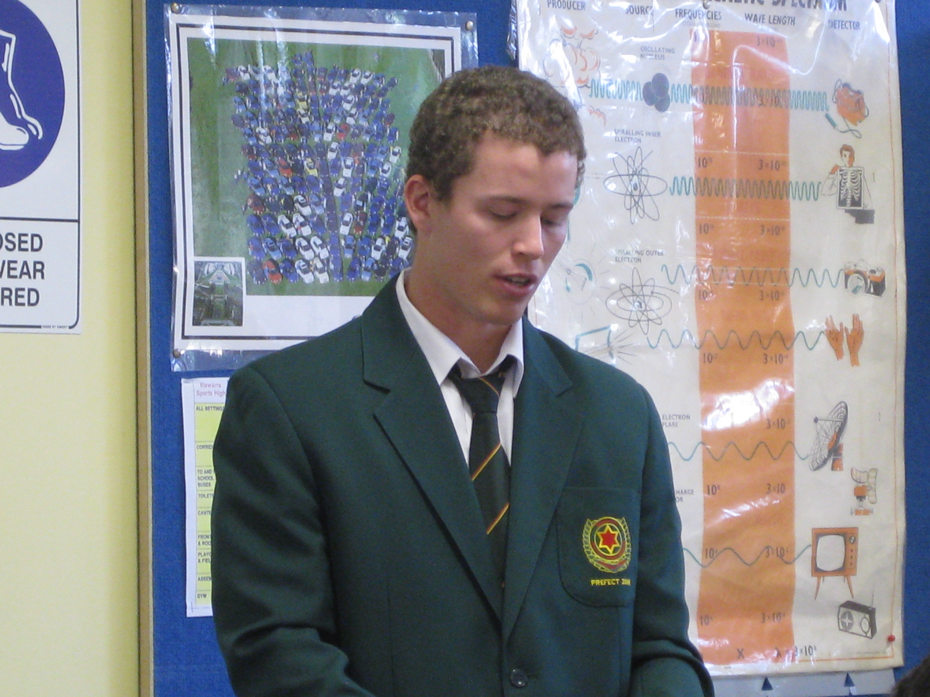

**]**

**Stephen Smith presenting what the new labs mean for students**

**ILLAWARRA DRAGON BOATERS OPEN DAY**

At The Illawarra Rowing Centre, Northcliffe Drive, Warrawong, (opposite speed camera)

**SUNDAY 26th SEPTEMBER, 10:00am - 12:00noon**

**ENJOY A PADDLE, HAVE FUN, SEE WHAT DRAGON BOATING IS ALL ABOUT, HAVE A CHAT AND ENJOY MORNING**

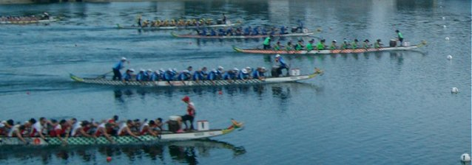**The minimum age is 12 years**

**For more information contact Lesley on 4261 5064 or Helen on 42961596**

Also, if you are interested, consider the Shellharbour Festival of Sport Dragon Boat Challenge  next March. See   [http://www.shellharbourcityfestivalofsport.com.au/](https://staffowa.det.nsw.edu.au/owa/redir.aspx?C=145aaae6a0df44e1a81362a86aaf1923&URL=http%3a%2f%2fwww.shellharbourcityfestivalofsport.com.au%2f)

**LEARN SAFE**

Free Workshops for parents and supervisors of Learner Drivers

Available from Wollongong City Council Tuesday, 30th November.

For further detail: Phone 42.27726 or Email: [rso@wollongong.nsw.gov.au](mailto:rso@wollongong.nsw.gov.au)

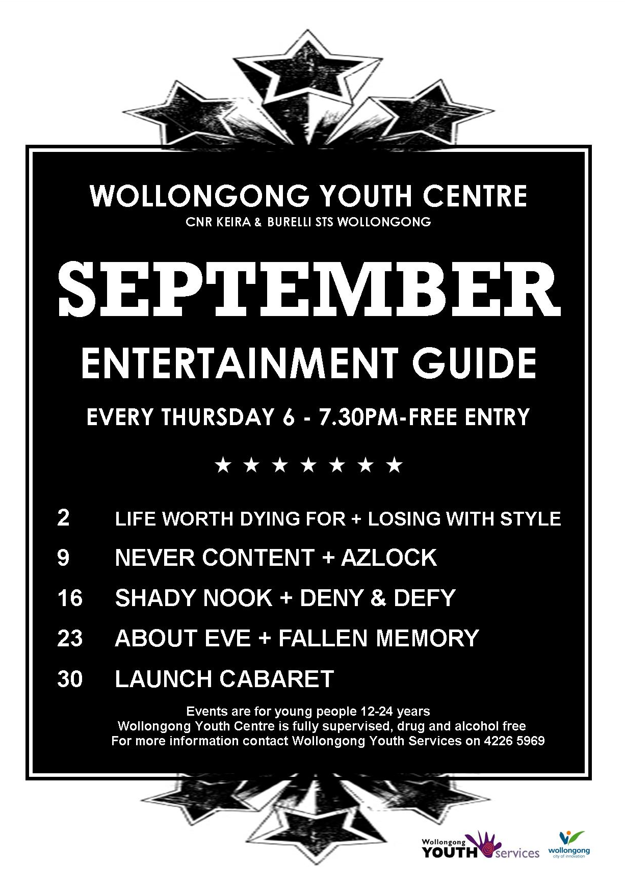

**Human Services**

**Community Services**

**Local Foster Carers Needed**

We are looking for local people to provide care for children and young people who are unable to live with their own families. Foster carers provide respite (e.g. one weekend a month), short term, or long term care.

Individuals, couples and families from varied backgrounds, cultural groups, Aboriginals and Torres Strait Islander people are encouraged to apply.

All carers receive training, support and financial assistance.

**Interested?** There will be information sessions:-

**When:** 13th October, 2010

**Times:** 10:30am – 12:00

**Venue:** Shellharbour Community Services, Lot 5 Burra Place, Shellharbour City Centre (down the arcade next to Rebel Sport and behind Greater Union cinema)

Refreshments will be provided. Please RSVP to Gabi Taylor on 42.556666 or email to [Gabi.Tyalor@community.nsw.gov.au](mailto:Gabi.Tyalor@community.nsw.gov.au) by 12th October



**TAFE NSW Illawarra Institute Dapto Campus My Productive Backyard Course**

The Outreach unit at Dapto Campus will be running practical workshops on organic gardening and sustainable backyard food production every Thursday from 14th October until 2nd December, 2010 through the ‘My Productive Backyard Course’. In this course you will learn all about growing veggies, composting, worm farming, keeping chooks and more. *This workshop series is a TAFE NSW Illawarra Institute Outreach Unit course.*

**Please Note: there is a $50 materials fee per student for this course. Here is no administration charge for this course.**

**T**o enrol in this course, please contact **Kathy Finigan** on 42218939 before 16th September, 2010.

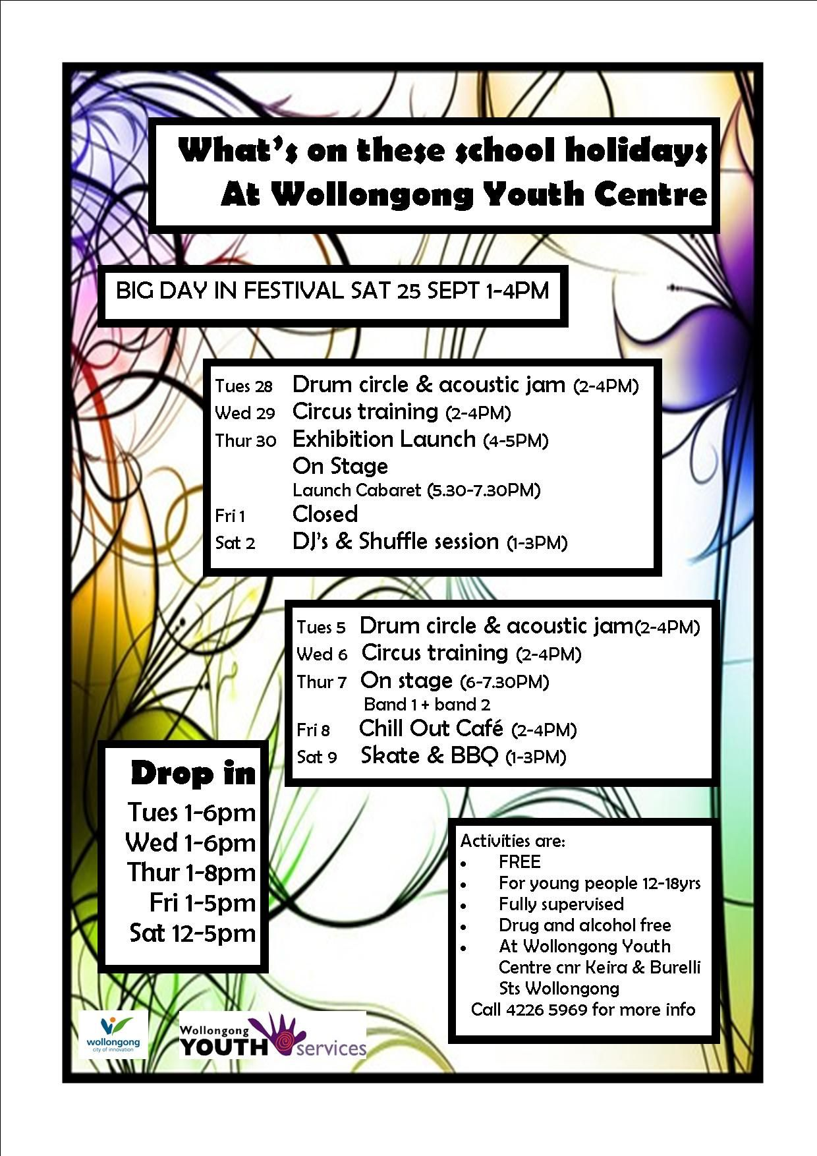

# 

# Logo header

# FAMILY CYCLE SKILLS AND ROAD SAFETY LESSON

# 18TH SEPTEMBER, 2010

# Course 1: 9am-12pm Saturday and

# Course 2: 1pm-4pm Saturday

# Lake Illawarra, King St, Warrawong

# Car Park opposite Wilsonś Bike Hub

As part of a Federal and State Government initiative, Bike Hub has been given funding to offer free cycle skills courses to adult cyclists. However, we thought we would take this further and offer training to all of our community members and children who will be given free training as part of Mobile Bike Rental and Mobile Bike Schools FAMILY BUG initiative.

Two courses will be run by Mobile Bike School qualified coaches of Austcycle, a division of Cycling Australia, and the Amy Gillette Foundation. The course covers basic cycle skills for beginners to intermediate riders and is aimed at teaching people how to use their bike for commuting and recreation purposes.

What you need to do and bring:

* You need to have a bicycle and helmet (if you do not have one, when booking ask about our hire arrangements); bring a water bottle;
* You need to book in your spots as there are limited spaces by calling 02 4231 4118 or email [info@mobilebikerental.com.au](mailto:info@mobilebikerental.com.au) (specify Bike Hub bike week)

Remember this is **FREE CYCLE SKILLS Training**

All coaches have qualifications in Austcycle, First Aid, and have Working with Children Checks. Human Services

**Enjoy a day with Aboriginal Discovery Rangers**

**and learn about culture**

**Men’s business** – tools, hunting, dance, boomerangs and didgeridoos.

**Women’s business** - traditional weaving, art, bush tucker and bush medicine.

**ABORIGINAL CULTURAL DAY @**

**Where:** Bomaderry Creek picnic area, Bomaderry Creek, Regional Park

**When:** Tuesday, 5th October

**Time:** 10:00am-2:00pm

**Meet:** Bomaderry Creek picnic area. Narang Rd.,

Bomaderry

**Bring:** Sun protection, snack, water

**Cost:** Child $5, Adult $8, Family $20

**Wollongong City Gallery**

**Spring School Holiday Workshops**

**THURSDAY 30TH SEPTEMBER**

10:00am – 12:00 noon

PASTEL DRAWING for 9 – 14 yr olds.

Elspeth McCombe – artist, tutor.

Learn simple techniques to draw the still life arrangement in front of you. In this step by step workshop you will use pastels and special paper to create your own still life artwork.

1:30pm – 3:30pm

SGRAFFITO for 9 – 14 yr olds.

Elspeth McCombe – artist, tutor.

Discover sgraffito, the art of scratching back into a surface after applying an oil pastel layer. Practice using different tools and techniques on a sample before you scratch your masterpiece.

**FRIDAY 1ST OCTOBER**

10:00am – 1:00noon

IMPRESSIVE PRINTS for 5 – 8 yr olds.

Tina Mackander – artist, art educator.

Explore relief printmaking using SCRATCH-FOAM plates by drawing, inking and hand printing.

1:30pm – 3:30pm

IMPRESSIVE PRINTS for 9 – 14 yr olds.

Tina Mackander – artist, art educator.

Explore relief printmaking using SCRATCH-FOAM plates by drawing, inking and hand printing.

**TUESDAY 5TH OCTOBER**

1:30pm – 3:30pm

AFRICAN MASKS for 9 – 14 yr olds.

Tina Mackander – artist, art educator.

Create fun and fantastic African-inspired masks using recycled materials, found objects and paint while listening to African beats.

**WEDNESDAY 6TH OCTOBER**

1:30pm – 3:30pm

DYNAMIC DRAWING for 9 - 14 yr olds.

Luciano Valeo – art educator, artist.

Explore drawing through a range of materials including pencil, paint and pastels.

**THURSDAY 7TH OCTOBER**

1:30 – 3:30pm

FELT MEDIA POUCH for 9 – 14 yr olds.

Meegan Knight – textile, educator.

Create your own media pouch from felt for your ipod, phone or media player. Children will learn basic pattern assembly, embroidery stitches and get to use an electronic felting machine.

**FRIDAY 8TH OCTOBER**

10:00am – 12:00noon

CANTASTIC soda can art for 9 – 14 yr olds.

Kate Blackburn – textile artist, tutor.

Make brilliant bugs, beautiful butterflies and fantastic flowers from soda cans.

1:30 – 3:30pm

MEXICAN CREPE FLOWERS for 9 – 14 yr olds.

Kate Blackburn – textile artist, tutor.

Come and create some colourful crepe flowers, their fun to make, and wonderful to look at.

EACH CLASS

$20 PER CHILD

FOR BOOKINGS & INFORMATION

PLEASE CALL WOLLONGONG CITY GALLERY

ON 4228 7500

**Springtime Softball for kids**

**For under 7’s, 10’s and 14’s**

Played at Dandaloo Sports ground, Dapto,

Monday’s, 6:00p.m. – 7:00p.m. from November 1st to December 13th.

Costs $25. All equipment provided.

Contact mobile, 0411 788 801 or email [softballillawarra@y7mail.com](mailto:softballillawarra@y7mail.com) or www.illawarra.softball.org.au

**WORKSHOPS**

**Wollongong Term 4 2010**

CatholicCare’s Family Relationship Services Program is funded by the Department of Families, Housing, Community Services and Indigenous Affairs (FaHCSIA)

[www.catholiccare.woll.catholic.org.au](http://www.catholiccare.woll.catholic.org.au)

**MY KIDS AND ME - Previously Triple C**

A workshop for parents who have had children removed from their care. Assists participants to identify parenting skills, strengths and resources and to develop relationships with their children.

CatholicCare, 25-27 Auburn St, Wollongong

6 Monday Mornings - 10am-12:00pm

11, 18, 25 October, 1, 8 & 15 November

Workshop Fee: $60

**PARENTING TEENS**

This 4 session workshop will explore many ways a family can handle parent-teen issues. Parents can attend the entire workshop, or individual sessions.

Session 1: Understanding your teenager

Session 2: Communicating with your teenager

Session 3: Setting boundaries and discipline

Session 4: Conflict management and self esteem

CatholicCare, 25-27 Auburn St, Wollongong

4 Tuesday Afternoons – 12:00noon-2:30pm

19, 26 October, 2 & 9 November

Workshop Fee: $40

**ROLLERCOASTER**

This 8 week program is to assist children who are experiencing parental separation, divorce or parents who have re-partnered. Rollercoaster helps children to understand change and loss; develop strategies for anger management and problem solving; and understand a whole range of feelings and emotions.

CatholicCare, 123 Gipps Rd, Gwynneville

8 Monday Afternoons – 4:00-5:00pm

25 October, 1, 8, 15, 22, 29 November, 6 & 13 December

Workshop Fee: $80 per family (regardless of number

of children from family attending)

**KEEPING KIDS IN MIND**

**A post-separation parenting program**

For parents of children two years and above. Learn how to deal more effectively with the emotional and practical issues of parenting after separation. Explores loss and grief in parents and children, communication with your ex-partner, anger,

assertiveness, power grabs and impact on children.

CatholicCare, 25-27 Auburn St, Wollongong

5 Tuesday Mornings 10:00am-12:30pm

9, 16, 23, 30 November & 7 December OR

5 Wednesday Evenings 7-9:30pm

17, 24 November, 1, 8 & 15 December

Workshop Fee: $50

**123 MAGIC & EMOTION COACHING**

This time tested workshop provides easy-to-follow steps for disciplining children aged 2-12 years without yelling, arguing or hitting.

CatholicCare

25-27 Auburn St, Wollongong

3 Wednesday Mornings 10:00am-12:30pm

27 October, 3 & 10 November OR

3 Monday Mornings – 10:00am-12:30pm

22, 29 November & 6 December

Workshop Fee: $30

**MENTAL HEALTH FIRST AID**

Mental Health First Aid is a 12 hour course which teaches first aid skills for mental health crisis situations and the early stages of mental health problems.

CatholicCare

25-27 Auburn St, Wollongong

2 Fridays - 9:30am-4:30pm

8 & 15 October OR

2 days 9:30am-4:30pm

Tuesday 7 & Wednesday 8 December

Workshop Fee $120

**WORKSHOP BOOKINGS**

**For bookings or information call:**

Campbelltown 4628 0044

Wollongong 4227 1122

Nowra 4421 8248

Other courses may be available on request.

Limited childcare may be available for some

Workshops

**CATHOLICCARE WORKSHOPS**

CatholicCare also offers the following workshops:

 Raising Resilient Kids

 Turbulent Teens

 Seasons for Growth

 Parenting Children with a Disability

 Challenging Behaviours

 Rollercoaster

 Hey Dad!

 Parenting Toddlers and Pre-Schoolers

 Ideas for Parents

 Pre Marriage Education

**ABOUT CATHOLICCARE**

CatholicCare is the Social Services agency of the

Catholic Diocese of Wollongong covering the

Illawarra, Shoalhaven, Macarthur and Southern Highlands

Regions.

We work together to make a difference in people’s

lives by offering opportunities for growth, healing and

hope.

CatholicCare is an inclusive organisation and

education workshops are available to everyone,

regardless of religious beliefs.

Services

**CatholicCare offers A Therapeutic Group for men and women experiencing anxiety and/or depression**

Presents principles from both Cognitive Behavioural Therapy (CBT) and Acceptance and Commitment Therapy (ACT).

* Learn about what keeps anxiety and depression going and how to reverse the cycle.
* Explore thoughts and feelings in a safe and friendly environment.
* Experiment with strategies for both challenging and unpleasant thoughts and feelings
* Set goals in line with your values to increase pleasurable activities and exercise and improve nutrition and sleep.
* Practise a variety of relaxation and stress reduction techniques
* Discover how to improve relationships and build your support network

**When:** 5 Fridays 1:00pm – 3:00pm

5th, 12th, 19th & 26th November and

3rd December

**Venue:** CatholicCare Wollongong, 25-27 Auburn St.,

Wollongong, 2500

**Cost:** $20 per session. Course fees to be paid at first

Week

**Bookings essential:** Phone 42549316

